**Course Specialist Year 11**

Student name: __________________________ Teacher name: ________________

Date: 18 Sep 2020

**Task type: Response**

**Time allowed for this task: _____45______ mins**

**Number of questions: _____6______**

**Materials required:** Calculator-Free

Standard items: Pens (blue/black preferred), pencils (including coloured), sharpener, correction fluid/tape, eraser, ruler, highlighters

Special items: Drawing instruments, templates

**Marks available: __45____ marks**

**Task weighting: __10__%**

**Formula sheet provided: Yes**

**Note: All part questions worth more than 2 marks require working to obtain full marks.**

**Question 1 (2.2.1, 2.2.2, 2.2.3) (6 marks)**

If $A=\left[\begin{matrix}1 & 0 \\ -2 & -3\end{matrix}\right]$, O is the $2×2$ zero matrix and I is the $2×2$ identity matrix, find

1. Matrix B given that $A-B=I$ (1 mark)
2. Matrix C given that $2A+C=O$ (1 mark)
3. Matrix D given that $D=B-AD$ (4 marks)

**Question 2 (2.1.4, 2.1.7) (7 marks)**

1. On the axes below, sketch the graph of $y=5 sec\left(x-π\right), 0≤x≤2π$. (3 marks)

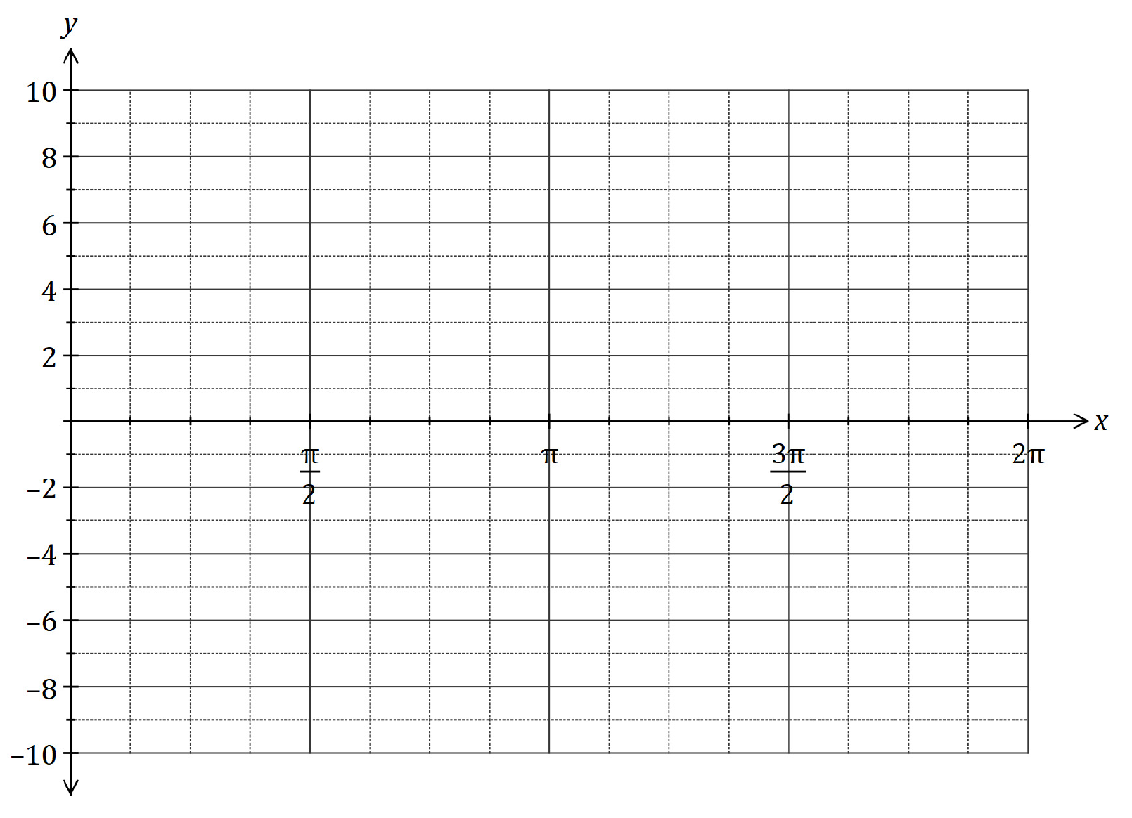

1. Find the general solution for $\sqrt{3} cos\left(x\right) - sin\left(x\right) =1$. (4 marks)

**Question 3 (2.2.3, 2.1.3) (6 marks)**

Let $A=\left[\begin{matrix}cos\left(α\right) & sin\left(α\right) \\ sin\left(α\right) & cos\left(α\right)\end{matrix}\right]$ and $B=\left[\begin{matrix}cos\left(β\right) \\ sin\left(β\right)\end{matrix}\right]$, such that $AB=\left[\begin{matrix}\frac{1}{2} \\ \frac{\sqrt{3}}{2}\end{matrix}\right]$.

Find $α$ and $β$ for $α, β∈\left[0, \frac{π}{2}\right]$.

**Question 4 (2.1.3, 2.1.5) (6 marks)**

Prove the following identity:

$$tan\left(θ-\frac{π}{4}\right)=\frac{sin \left(2θ\right) - 1}{1 - 2\sin^{2}θ}$$

**Question 5 (2.2.11) (9 marks)**

If $A=\left[\begin{matrix}4 & 1 & 1 \\ 3 & -1 & 1 \\ 1 & 1 & 0\end{matrix}\right]$ and $B=\left[\begin{matrix}-2 & 2 & 4 \\ 2 & -2 & -2 \\ 8 & -6 & -14\end{matrix}\right]$

1. Determine AB. (2 marks)
2. Express $A^{-1}$ in terms of B. (3 marks)
3. Solve the system $\left\{\begin{matrix}4x+y+z=8 \\ 3x-y+z=4 \\ x+y=3\end{matrix}\right.$, clearly showing your use of $A^{-1}$. (4 marks)

**Question 6 (2.2.4, 2.2.5, 2.2.6, 2.2.7, 2.2.8, 2.2.9, 2.2.10) (11 marks)**

1. Determine the matrices that produce each of the transformations described below:
2. a rotation clockwise about the origin by $90°$ (1 mark)
3. a dilation parallel to the y-axis by a scale factor of 2 (1 mark)
4. a reflection in the line $y=x$ (1 mark)
5. Show how to obtain the single transformation matrix T, given that T is the result of applying the transformations given in part a) in the order listed [i.e. a rotation clockwise about the origin by 90°, followed by a dilation parallel to the y-axis by a scale factor of 2, then a reflection in the line $y=x$]. (2 marks)
6. $∆ABC$ is translated left by 1 unit and down by 2 units, then the transformation matrix T in part b) is applied to it. The final image $∆A'B'C'$ is shown below:

1. Determine the coordinates of points A, B and C in exact form. (4 marks)
2. Determine the exact area of $∆ABC$. (2 marks)